WORKSHEET 1

**Student Name: Priyansh**

**UID: 20BCS5670**

**Branch: CSE**

**Section: 903-A MM (DWWC- 43)**

1. **Fire and Ice Program Code:**

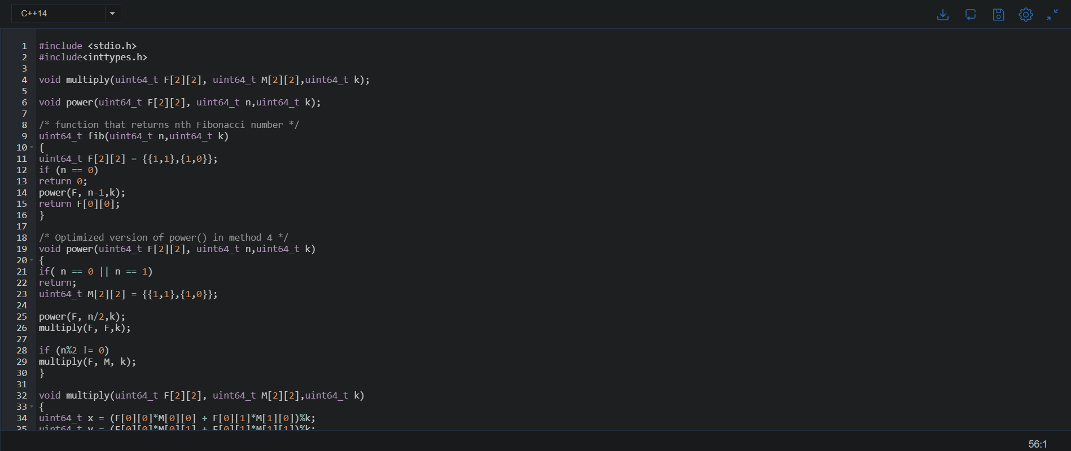

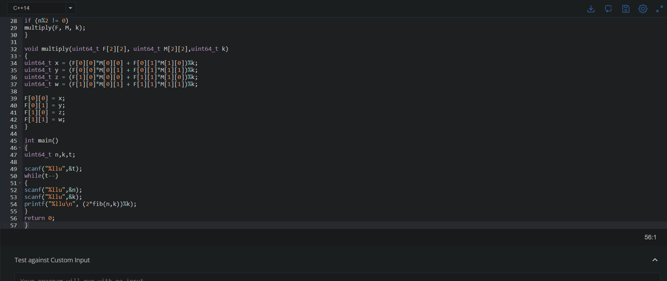

**Output:**

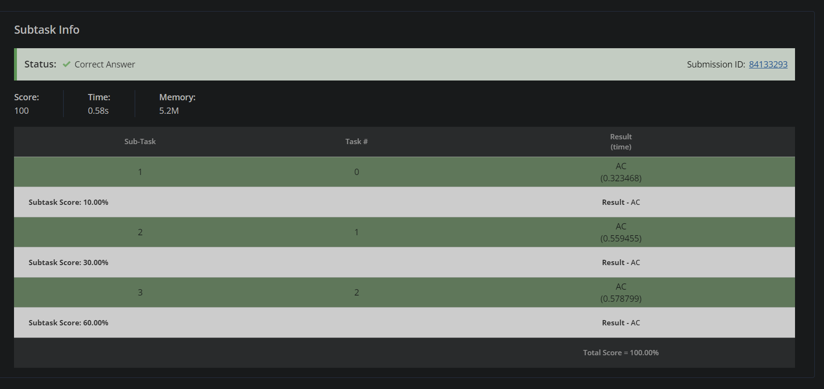

1. 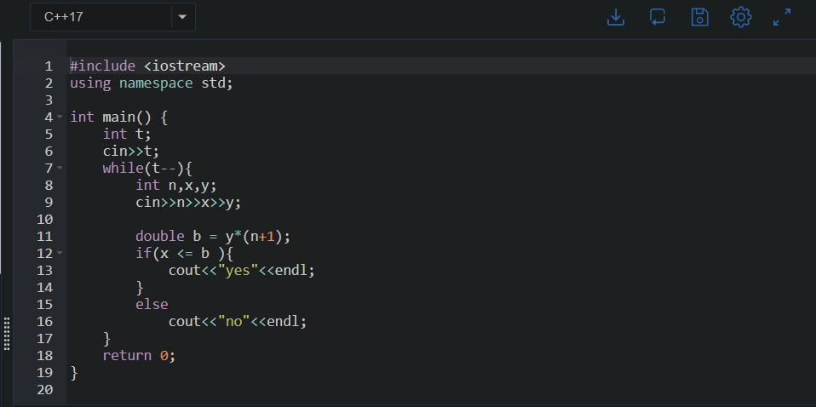**Gold Mining Program Code:**

**Output**

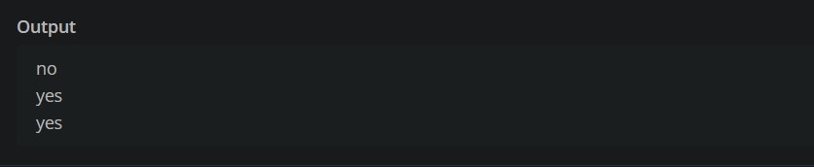

1. **The Lead Game Program Code:**

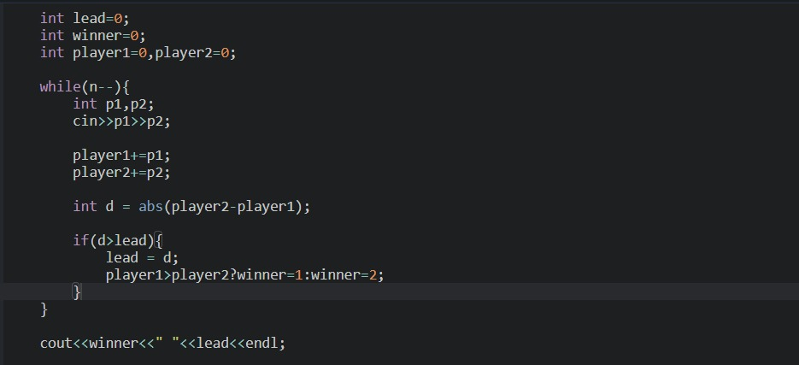

**Output:**

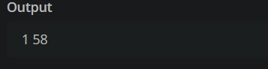

1. 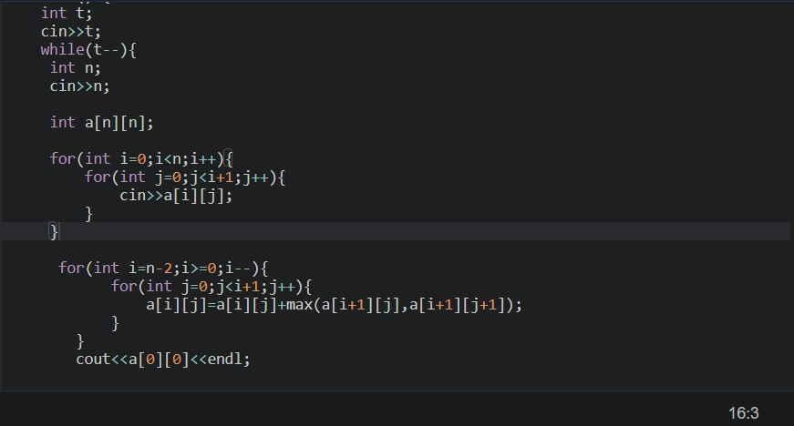**Sums in a triangle Program Code:**

**Output:**

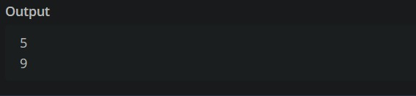

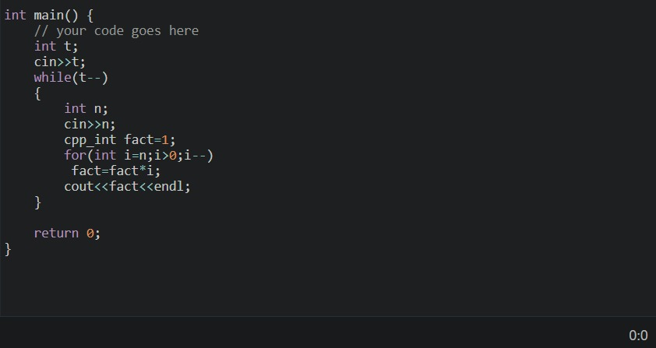**5.Small Factorials Program Code:**

**Output**

